How to use S3 to host Static Website for FREE

1.)S3🡪Create bucket🡪 static-web-galaxy-demo(bucket name 🡪universal)

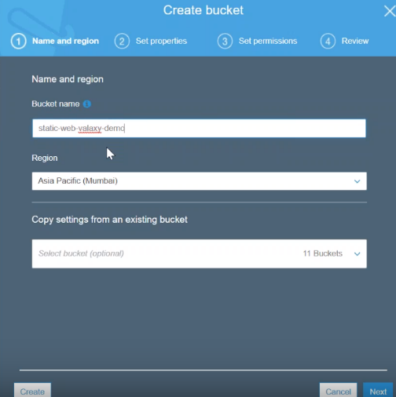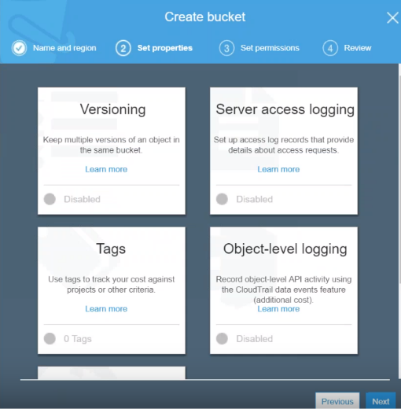

2.) No need to change any of these.

3.I just want to make public access given to this bucket.

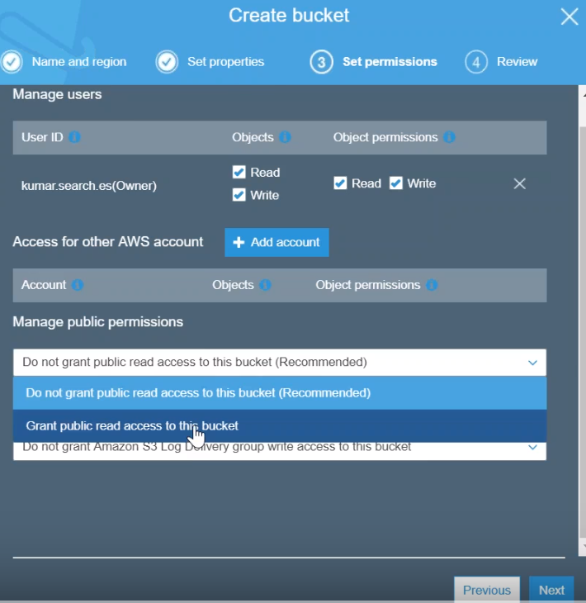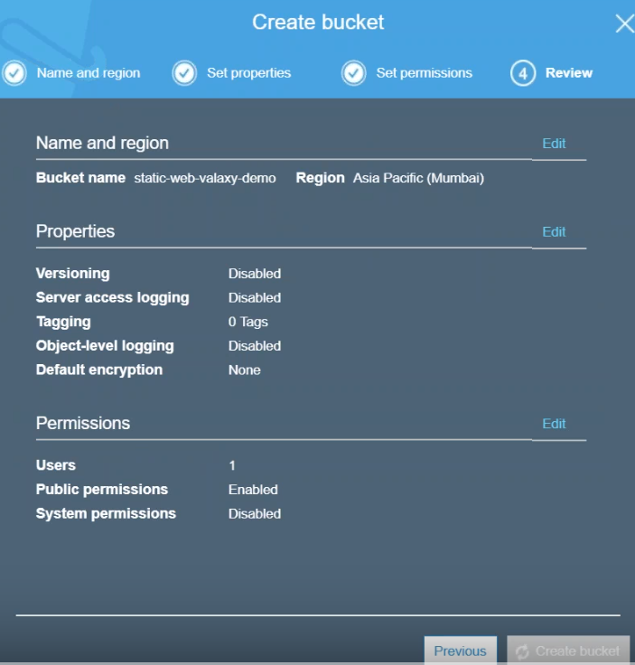

4.) create bucket.

5.) Goto bucket and upload index.html,error.html page..

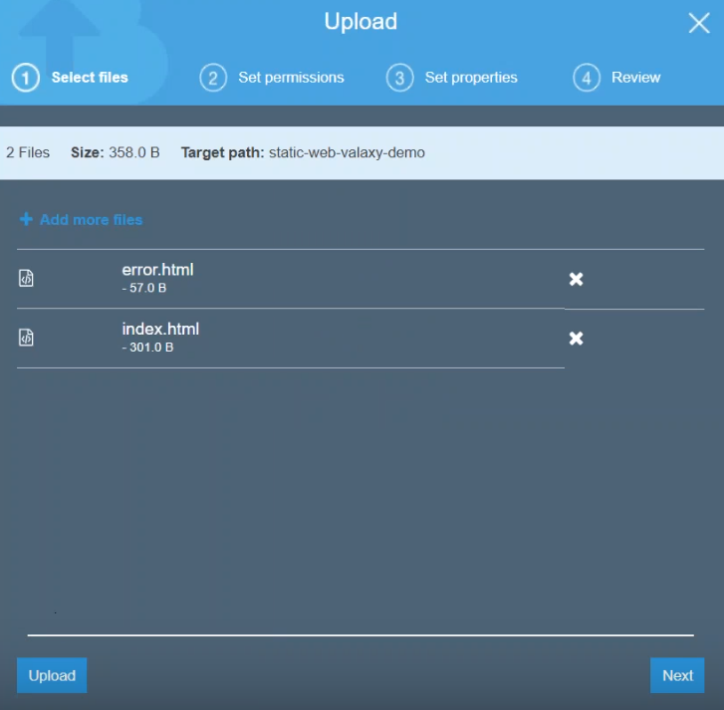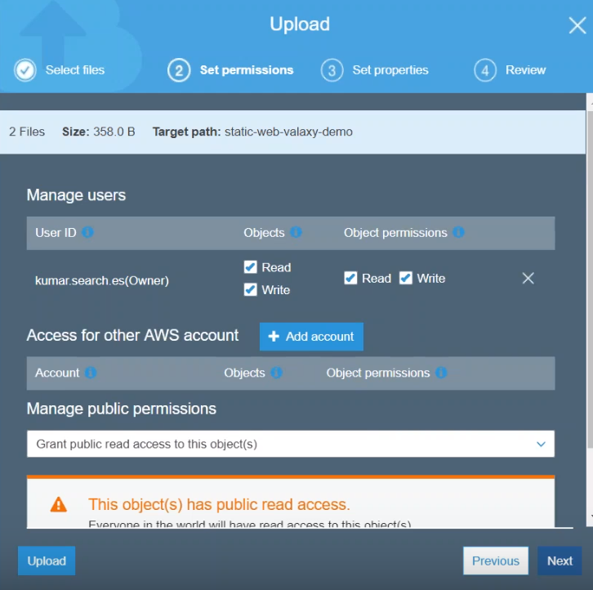

6.) Give public permissions for these objects.

8.)next and

9.) upload.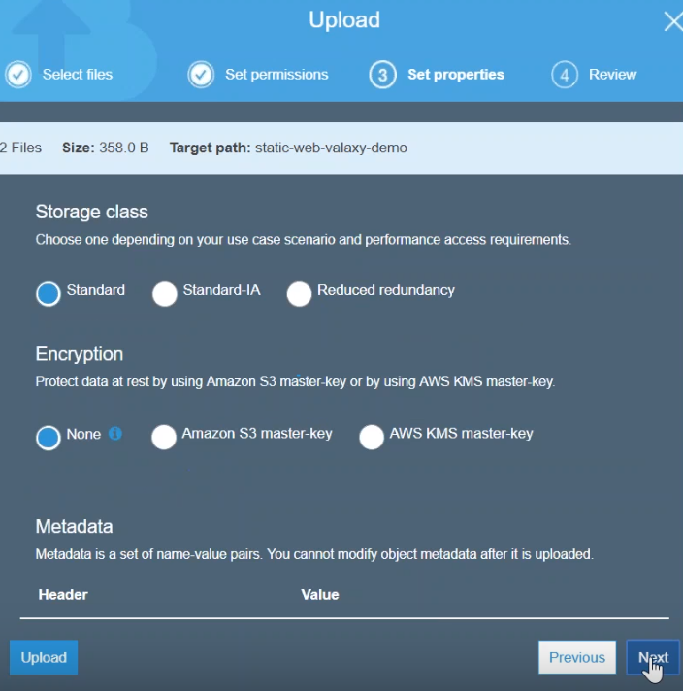 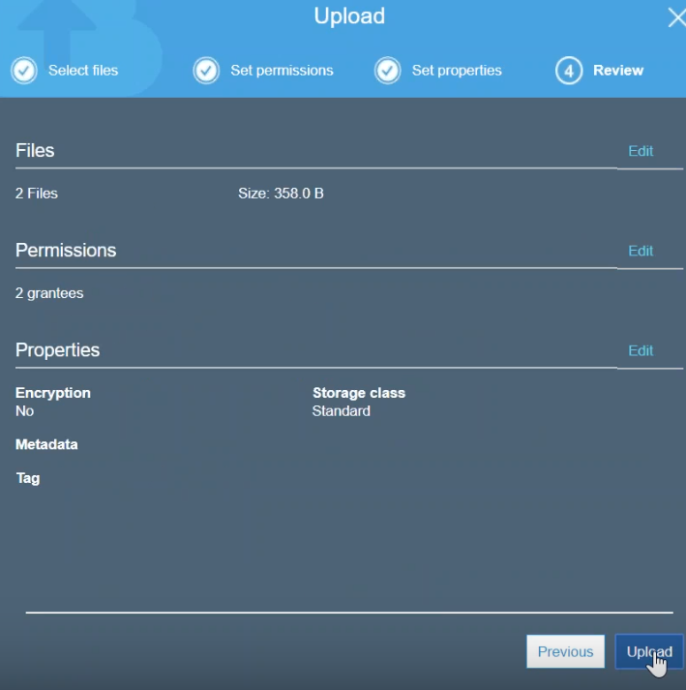

10.) I need some images also for my website as well..so I am just going to create a folder (images)

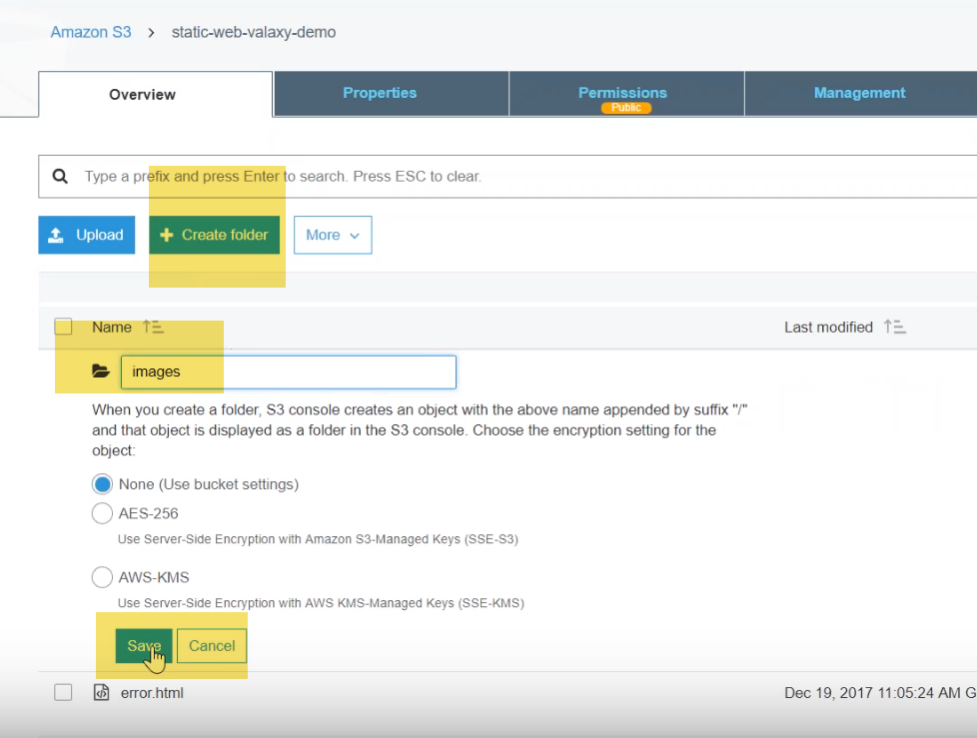

11.) Upload some images to my images folder.

FOLLOW SAME STEPS OF UPLOAD ABOVE…

12.) I have uploaded all the necessary files for our static website.

13.) Pending is configuring this website now …

although I will have a public URL for my index.HTML.

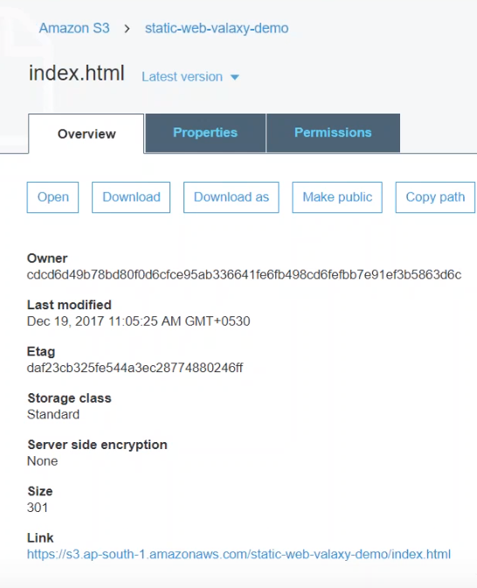

This URL but you can see here this is accessible through Ugly url.., and we don't want that.

We want our bucket name as a website name.

14.) BUCKET-🡪 properties -🡪static web hosting.

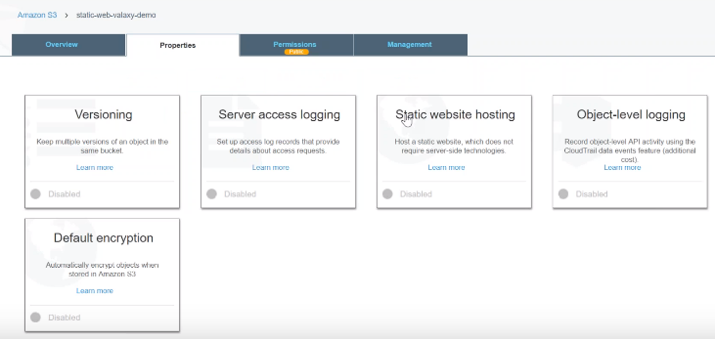

15.)All you have to do is:

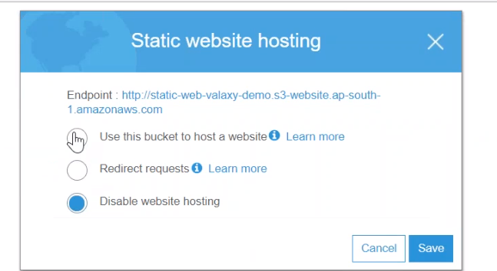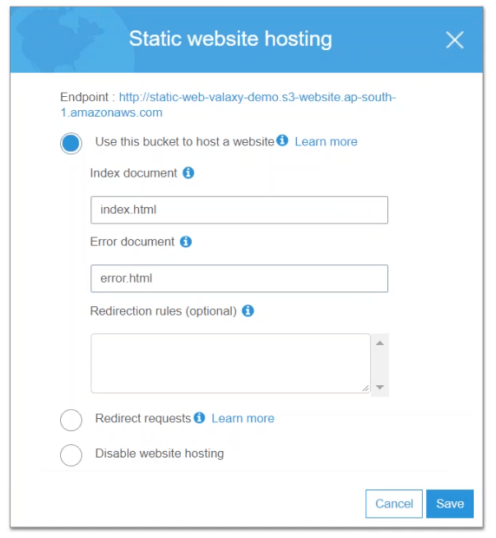

Select: use this BUCKET to host a website.

Enter: index.html, error.html.

16.) Copy that endpoint.. open the new browser window 🡪put my URL

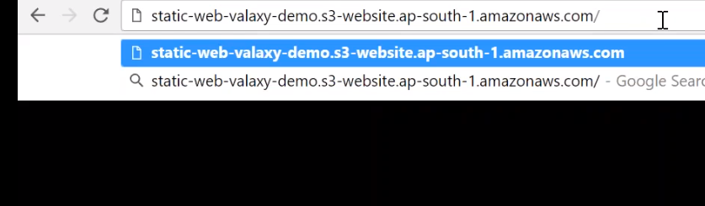

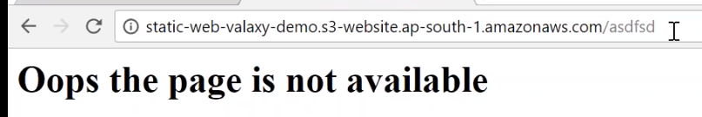

**NOTE:** I have error.HTML pagr…

So if somebody is trying to hack something …let's say that is they're looking for a page which is not there and automatically they will be redirected to my error.HTML page …

# Demo: Capture and Store S3 Static Website Access Logs

# how to set up and access logs for your static website…in my s3 account.

# I have already static website up and running and you can see the URL here..

# and if you go for an error.HTMl

# if you want to capture all this browser information

# who is hitting my page

# what is IP address of them

# what is the process version they are using whether it is Mozilla Firefox

# the best way to do it is capture the access logs and store it in a bucket… so that you can analyze them using a Splunk or an elastic search.

# 

# Bucket🡪 properties -🡪server access logging … enable logging.

# It will is ask you, where you want to put your logs into… So I am going to say I have created a new bucket called “access-logs”

# 

# prefix them with that web site logs

# logs will start rolling in another five or ten minutes and you should be able to retrieve them and access them anytime.

# usually the static website logs takes about five to ten minutes to start appearing on your destination bucket. So instead of waiting I'm just showing you my access locks bucket where the different types of logs are prefixed with different tags….

# S3 Sync Across AWS Accounts | Move Objects | Copy S3 To Another AWS Account

# how you can sync/copy s3 buckets across AWS accounts…

# 1.)First, we need 20 digit AWS account number for the destination account.

# So that means that we need a source account and the destination account.

# 2.)my source account is trainer-admin…

# I have an s3 bucket : static web-valaxy-demo…This is my source account…

# 

# 3.) destination account :Gurukul and I have an s3 bucket which is called as static website ..It is empty…

# Step-1: Get 12 digit account number of my destination account …

# billing management

# AWS S3: Object Versioning | How to enable versioning on S3 Bucket?

# you how to use s3 versioning…, so that you can roll back two changes when something goes wrong.

# 1.) Here I have my s3 dashboard open, where there is an static website configured there is an index.html and error.html..

# 2.) go to my properties you can see here the static website is configured up and running whereas my versioning is not enabled.

# 

# 3.) if I open my static website this is how the page is looks like.

# 

# the index.html and it says the version number but this is a version number that I have written they're not tracked by Amazon…

# 4.) if I want to have my versioning enabled and tracked by Amazon.. All I have to do is go here go to versioning in my bucket and click on enable versioning…

# 5.) from this moment onwards all my bucket objects will have and version attached to them…

# 6.)there will a hash map and you will not be able to view the hash map but you will know that come as one is tracking both objects..

# 7.) so if I go ahead and open that object you can see here this is the latest version.

# 

# and if I click on this link the latest version will open..

# 8.) ahead and change the subject and upload NEW INDEX>HTML it.

# 

# 9.)make sure that it has public permissions so that we can have access to it when you are accessing.

# This file indirectly overwrites an existing file …

# 10.)Something wrong with this website and you have want the roll Back,

# go to the object to where the error is and you can go choose this option and delete the latest version..

# 

# index.HTML pointer will be moved to the older version and you will be able to access it…

# Secure S3 by identifying buckets with "Public Access"

# I am going to show you one of the most common security scenarios that are faced by enterprises… Nowadays you read a lot of articles..., saying s3 buckets have been left with public access permissions or poor permission settings that enables other people who are not authorized or having valid business use case to access your s3 pockets.

# 2.) if you have a having one or two buckets it is easy to manually go ahead and check those buckets but If you are having a lot of buckets in your account????

# 3.) the easiest way to do that is come to your dashboard ---🡪if you click on this search for buckets …

# 

# Amazon gives you two options now

# a.)you can search for buckets with public read access… it automatically filters the buckets for you and says that I have one bucket which is having public read access .

# b.)so if I want to find all the buckets with public write access all I have to do is click on this option and say bucket with public site access…

# 

# c.) we want to search both of them for that as well have Amazon as a written a pre-written function so if you click on that it automatically will list which will fall under either of those two categories.

# In this way, you can quickly identify which buckets are in public domain and which are accessible by third party people or people with unauthorized access ….

# 4.)In addition to that Amazon also gives you this bright yellow color marker and an access section to clearly identify buckets which are having public permissions.

# 5.)you can also click on this one this option that it says that public so it automatically will filter you with the public read and write access ….

# Make sure that you don't have any pockets with public read/write access unless and until it is necessary .

# REVOKE these permissions

# go to this bucket 🡪 permissions

# 

# There is public access to everyone.

# click on this one and remove the list objects here

# and click on save…

# T

# This bucket is no longer public and you can see here the permissions is gone here …

# 

# if I go back to my buckets and say search for all buckets which are publicly readable and there is nothing in my account…

# AWS S3 Cross Region Replication - Data Replication Across Continents

# how to move data from one region to another region using Amazon s3 cross region replication.

# We just need two buckets both of them with versioning enabled and then using the advanced management options, we are can replicate the data from one region to another region.

# 1.)S3 dashboard 🡪create a source bucket.

# 

# Cr_source_bucket and I am going to enable versioning

# other actions as default .

# 2.) destination bucket

# put it in Virginia…,let me enable versioning .

# 3.)Gto management -🡪 replication🡪 click on add rule

# 

# add all the contents and

# keep the status as enabled and

# replicate any encrypted object as well

# 4.)Chose my destination bucket

# 

# destination bucket

# Select s3 KMS and

# Storage class :RRC

# 5.) I don't have an iam role setup for this one.

# So I'm not going to allow Amazon to create a new role for me to do this function.

# 

# So click on save if you have an existing role, you can choose that otherwise you see here it's creating a new role and it has done that….

# 6.)Now replication feature has been enabled.

# let us go ahead and upload some objects and see whether we can replicate the data

# 

# objects have been uploaded and it is reflecting here on my source bucket now… let me head over to my destination bucket and see if the gate has been duplicated …you see here the data is uploaded at 11:01

# l

# Also see the storage class has been moved to reduce redundancy storage

# Configuring AWS S3 Event Notifications | Notify SNS Topics through Email

Lets see how you can use s3 event notification to get updates of anything happen in your bucket.

Let us say, you have shared a bucket with your customers or partners and you want to be notified if they are uploading new files… then this is going to be really helpful to you… because you can trigger an SMS notification or an email notification or an SQS or lambda processing.

Here, we are going to use SNS to send us an email notification.

**prerequisites**

1.)creating an SNS topic and then updating the topic with the necessary policy permissions so that the bucket can push messages to that topic.

2.) subscribing to the topic - with an email address .where we would like to receive our notification and Finally we are going to inform s3 bucket so that it will know where it needs to send the messages.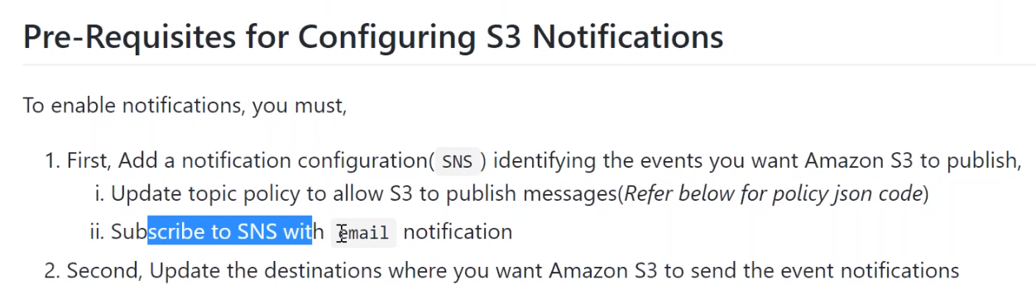

a.)go to SNS, create topic…

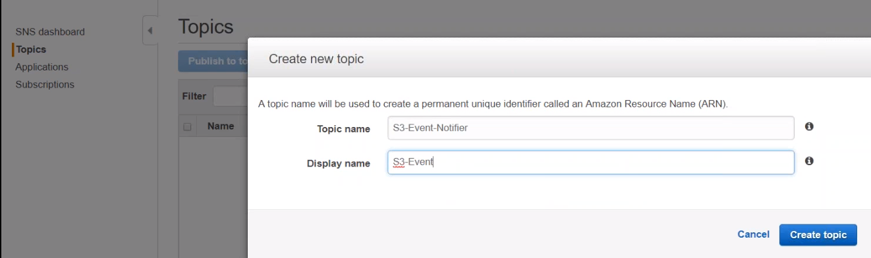 2.) update the policy…

So for updating the policy, let us choose **edit topic policy-🡪advanced view**

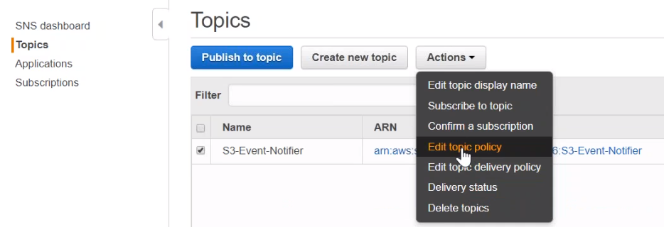

Here you have the default policy.., but I am only interested in the ARN number.

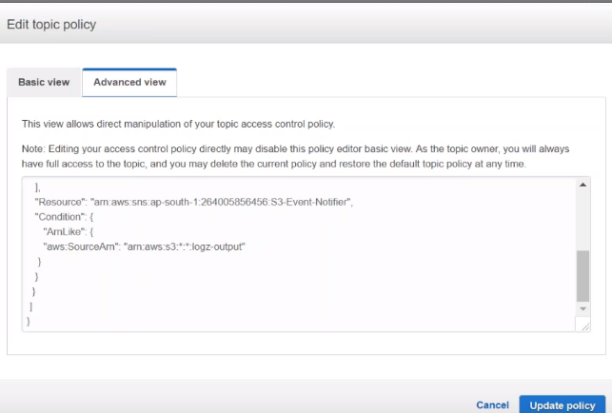

* Just give Bucket name
* ARN Number

3.) subscribe to this topic.

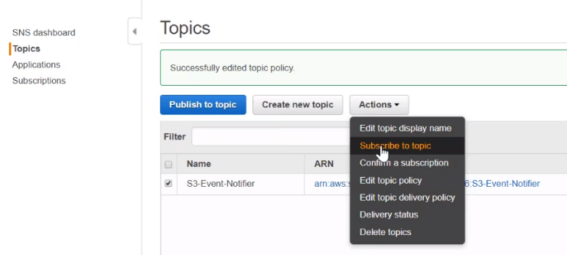

choose email protocol, and update the email address…

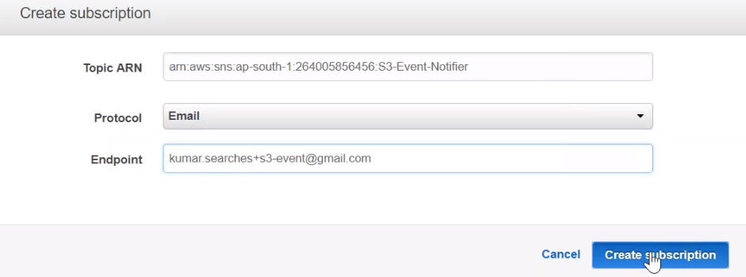

4) if I go to subscriptions you will find that it is under pending …

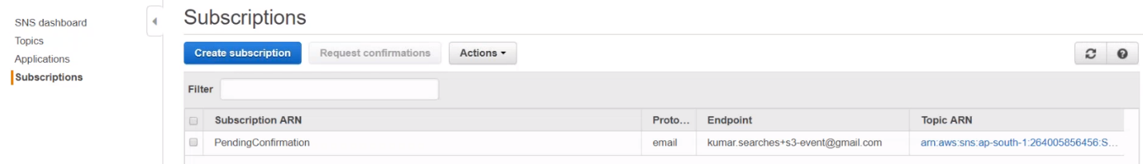

Confirm using gmail…

5.)Goto bucket🡪properties🡪events…>Create event…

If there is an existing event let us go ahead and delete that event..

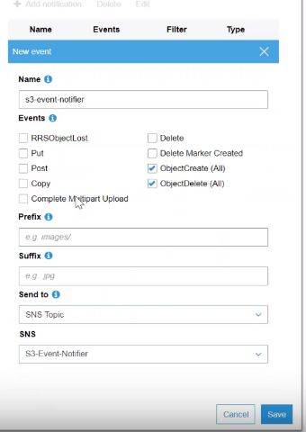

Name: s3-event-notifier.

Events: I want to be notified for all objects.

Prefx: don't filter it by any prefixes or suffixes.

Sendto: go ahead and choose SNS topic and see notifier ….

6.)We will receive email to gmail, saying : an topic is configured …

let us upload something here and then see whether we are getting email notification.

so I'm uploading a new object called a picture. jpg and I should be getting an email anytime.

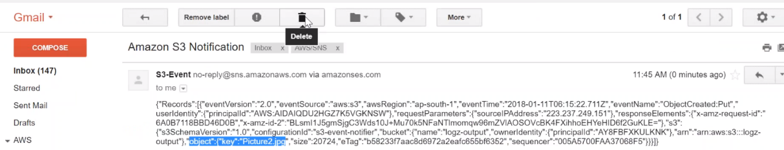

We can see under the bucket logs-output, there is a picture .jpg.

# AWS S3 Performance Improvement | 7 Tips | Best Practices | Recommendations

# What is Cloudfront? | How to setup CDN in AWS? | Setup Cloudfront